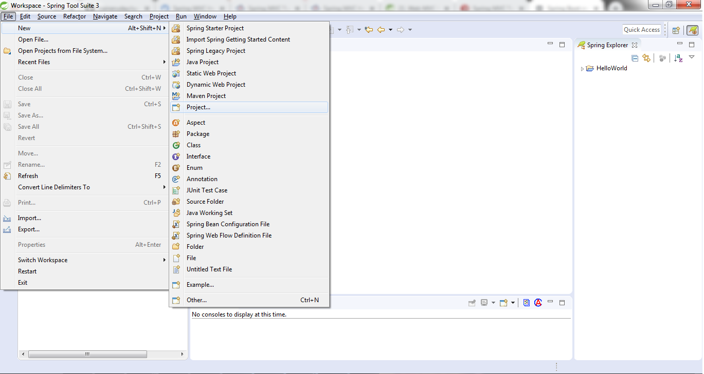

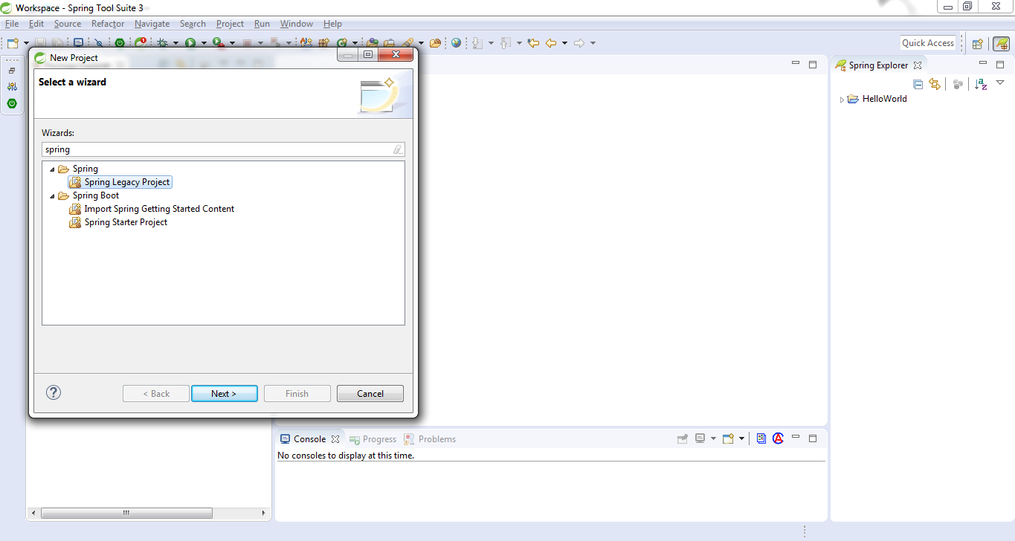

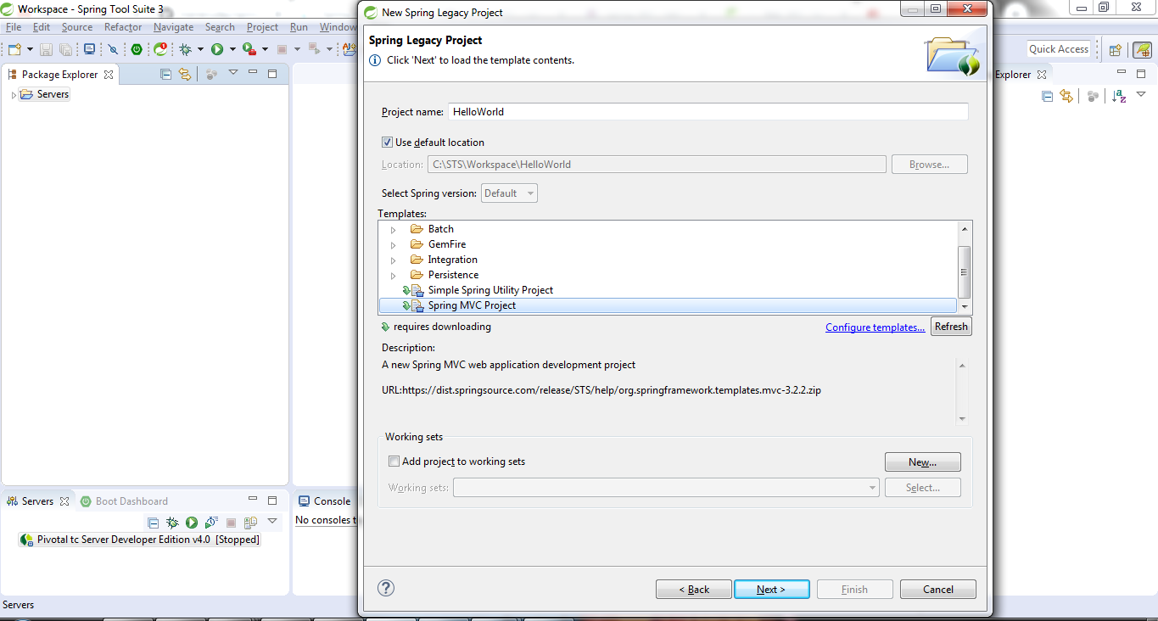

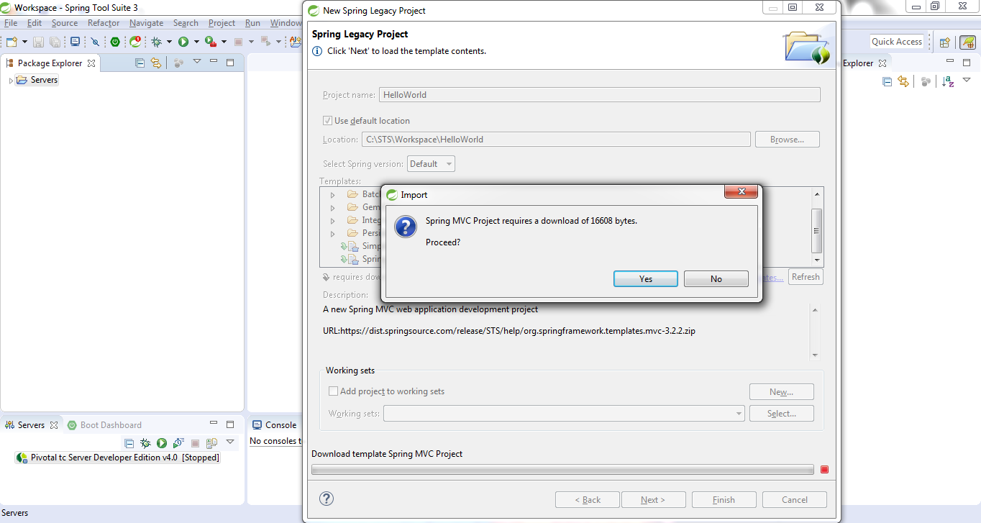

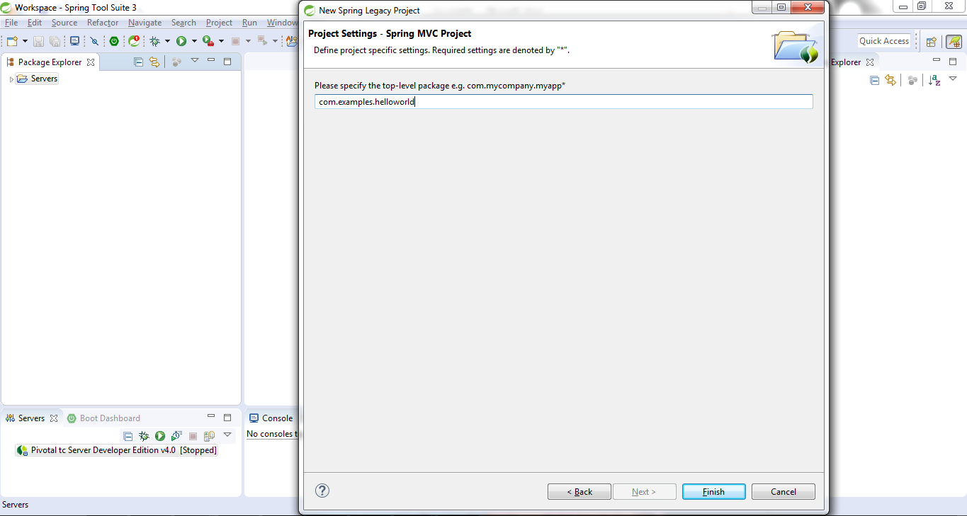

Click on finish and wait for few minutes to create spring mvc project

Once the project is created it looks like below

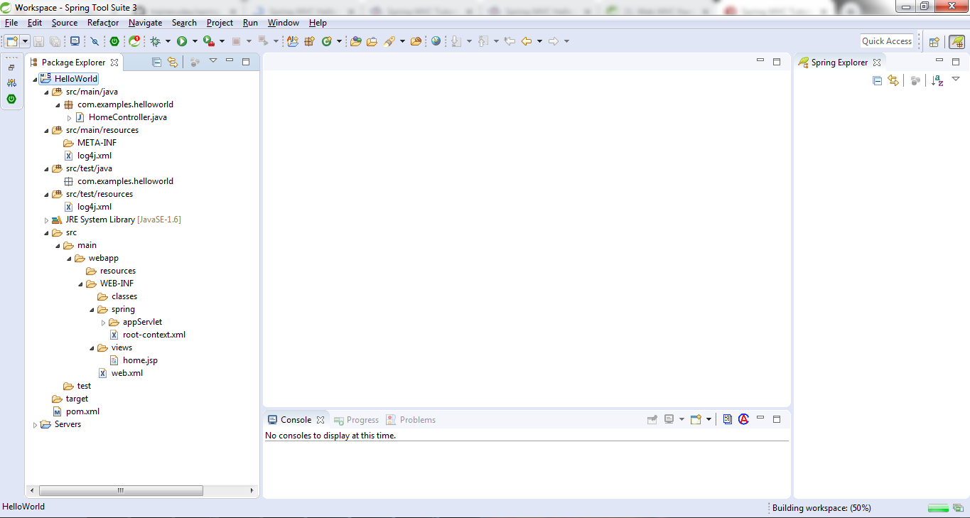

Open pom.xml file and search for the line contains word <build> and then add below line after this

<finalName>HellowWorld</finalName>

Add Jetty plugin

<plugin>

<groupId>org.eclipse.jetty</groupId>

<artifactId>jetty-maven-plugin</artifactId>

<version>9.2.10.v20150310</version>

<configuration>

<scanIntervalSeconds>10</scanIntervalSeconds>

<webApp>

<contextPath>/HellowWorld</contextPath>

</webApp>

</configuration>

</plugin>

